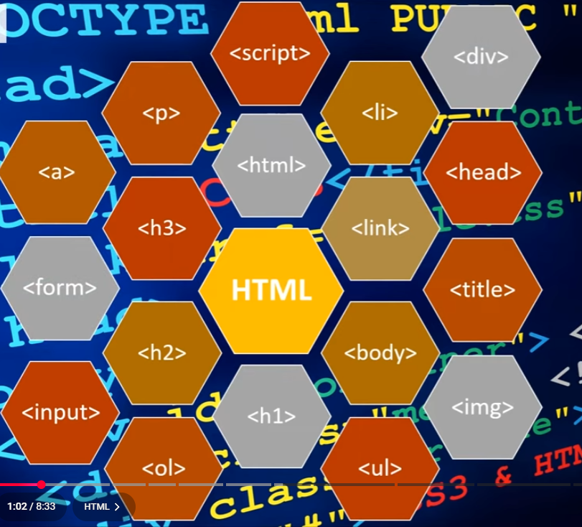
<HTML> - all documents start and end with it
<H1> <H2> <H3> - Headings
<Body> - where the majority of text goes, starts and ends in itself
<Title> - Displays Title
<p> - Paragraph – New lines
<img> - creates a holding place for an image
Img has 2 attributes:
Src – Source – gets the path to the image
Alt – Alternate – Displays text as insurance of if the image does not display
<a> = Hyperlink, (Also uses hred which gets the links destination)

<ol> - Ordered list
<ul > - Unordered list (Bullet points)
<Li> - Defines each item in the list
/HTML and /Body indicate the end of each respective area

